**Linux**

**Task 1-13**

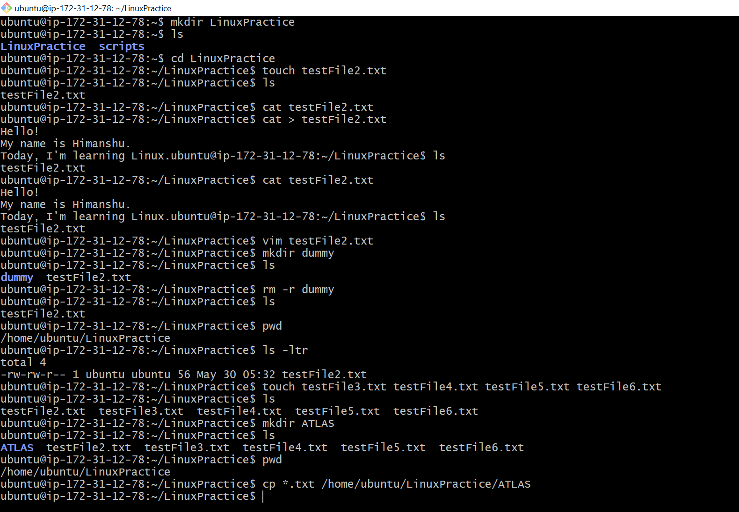

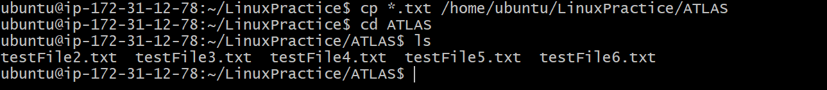



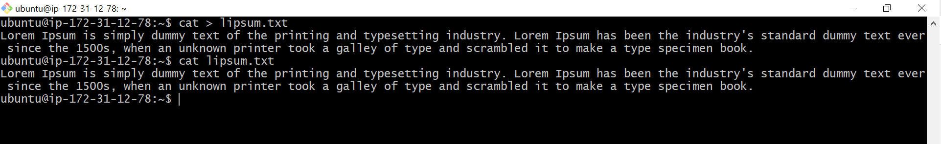

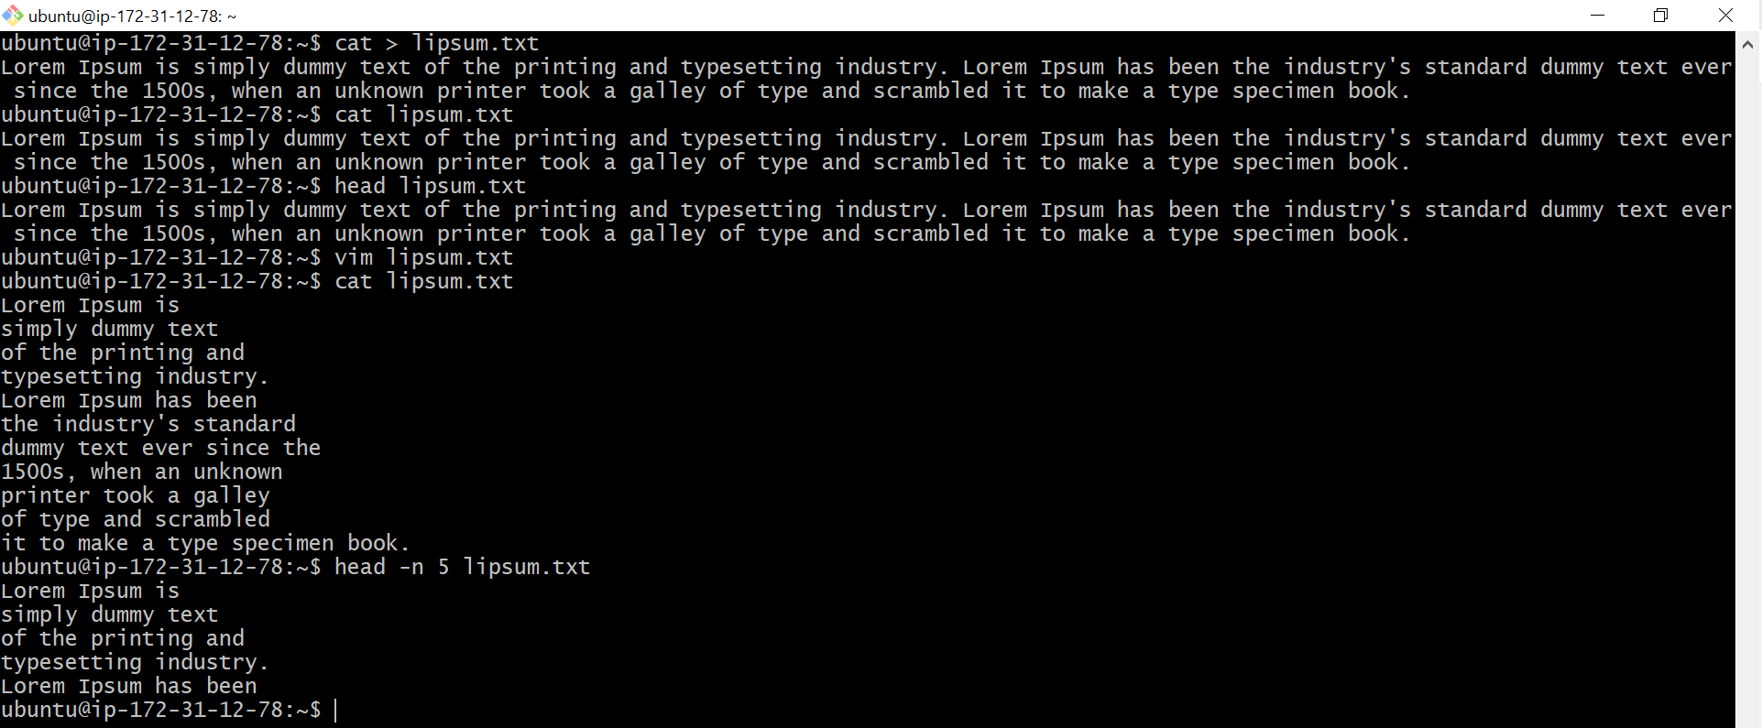

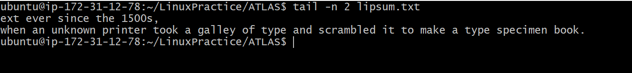

**Task 14**

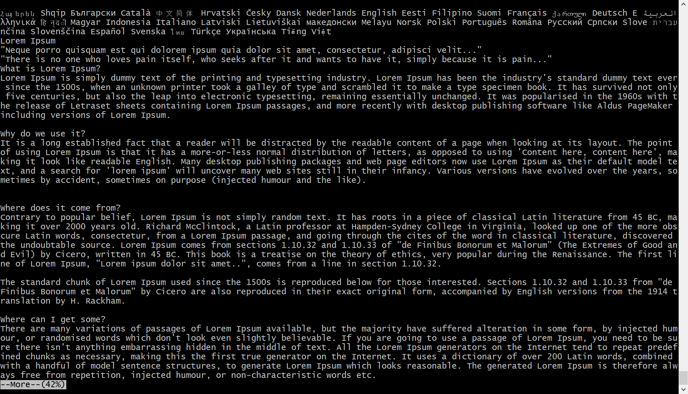

**Task: 15**



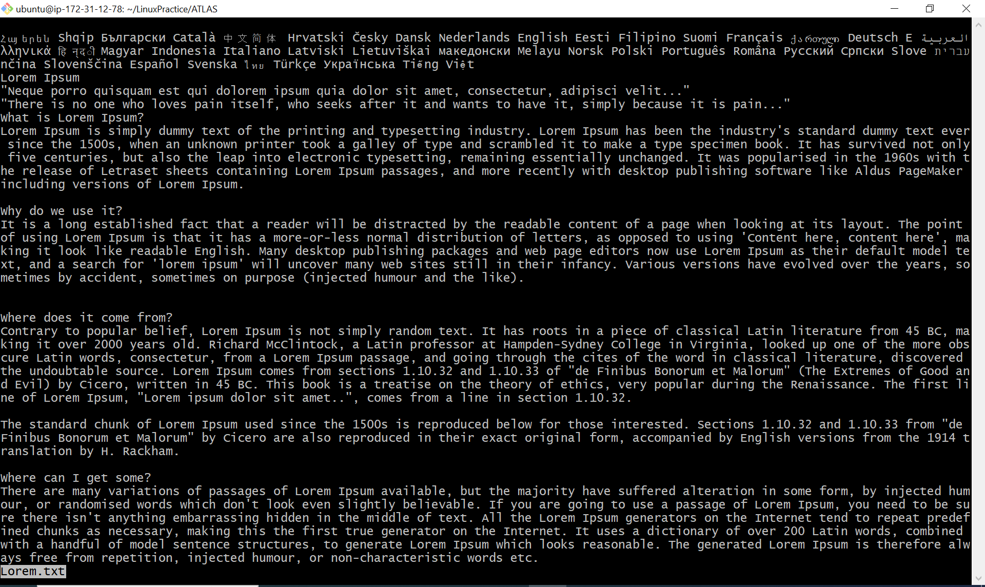

**Task 16:**

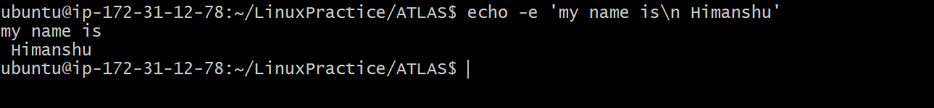

**Task 17:**

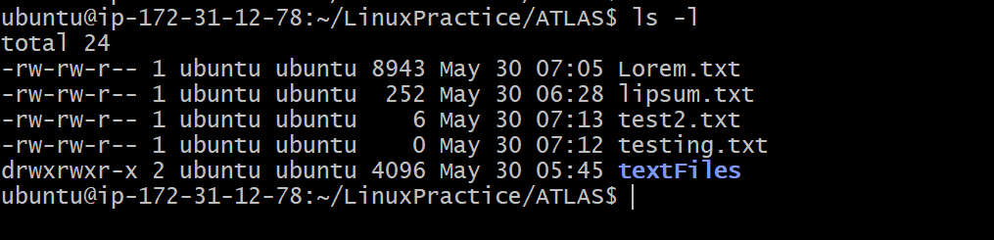

**Task 18:**

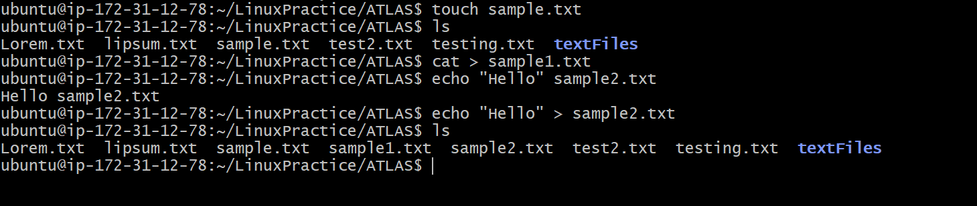

Touch command: this command will create a file without asking to enter text.

Cat command: with contact we can create files and also we can contact files

Echo command: this command enables the user to enter the text in double quotes and redirect it to the file.

Task 19:

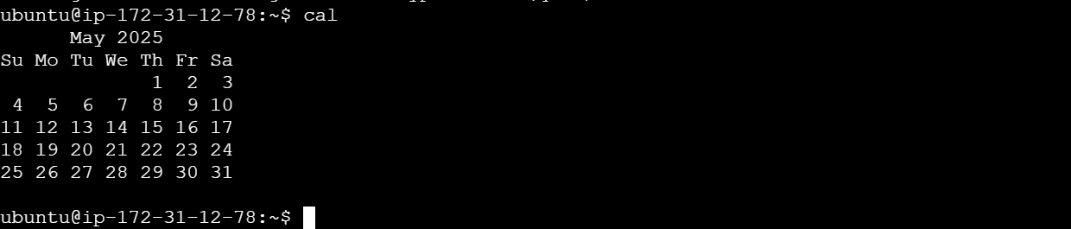

Task 20:



Task 21:



Task 22:



Task 23:

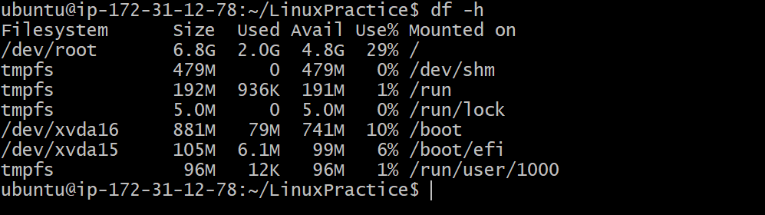

Task 25:



Task 26:



Task 27:

. Represent current directory

.. Represents parent directory

Task 28:

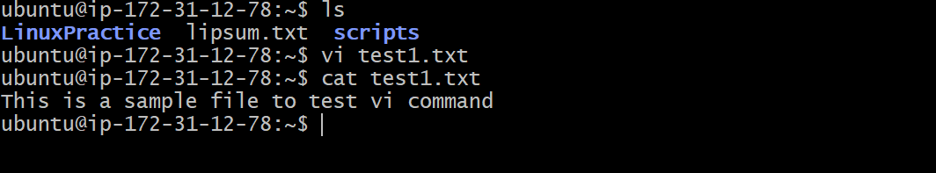

Task 29:

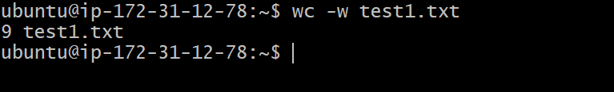

Task 30:

cat -b test1.txt : this command will give the output line by line with numbered format.

Task 31:

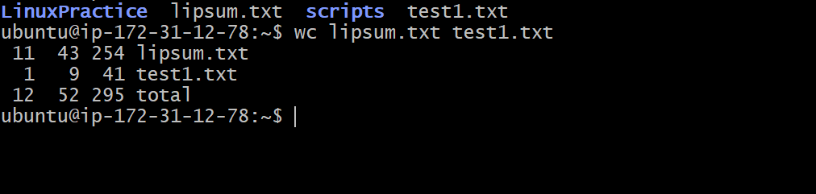

Task 32:

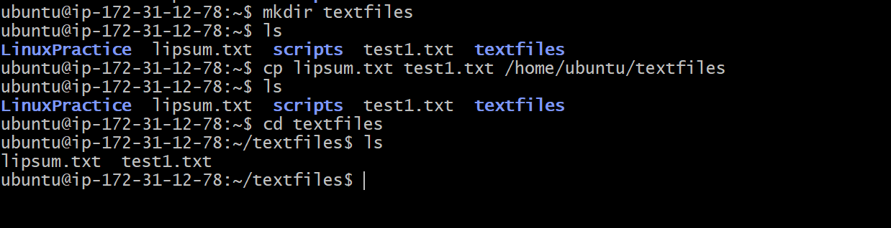

Task 33:

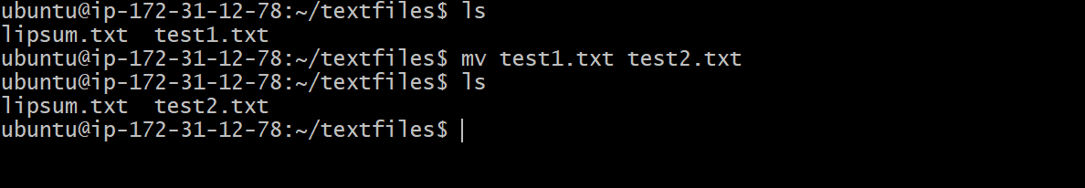

Task 34:

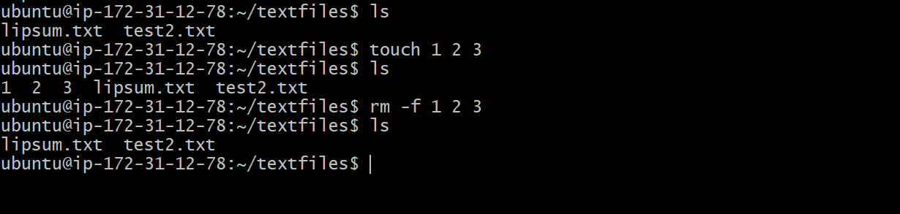

Task 35:

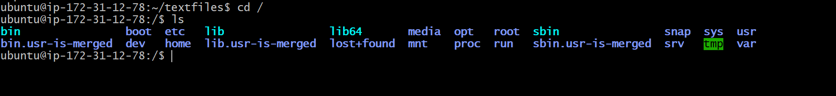

Task 36:

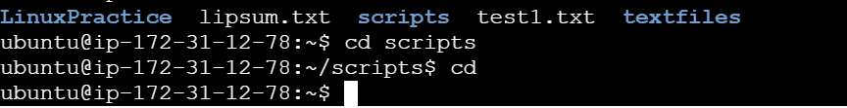

Task 37:

